# Deploying html file from git repo to container (on custom bridge n/w)
-Anushka Gaikwad

- Launched slave-1 and install and started docker on it.
- Create a job-1 on Jenkins pipeline in which I’ve first deployed my index file from my git repo’s 2025Q1 branch , created custom bridge network, created container and binded over port 80, and copied file in container.

pipeline {

agent {

label {

label "slave-1"

}
}

stages{

stage ("deploy repository") {

steps {

echo "cloning repository..."
git branch: '2025Q1' , url: 'https://github.com/Anushka-gaikwad/Repository-1.git'

}
}

stage ("deploy file") {

steps {

script {

sh '''
sudo docker rm -f c1
sudo docker network create test
sudo docker run -dp 80:80 --name c1 --network test httpd
sudo docker cp index.html c1:/usr/local/apache2/htdocs

'''

}

}

}

}

}

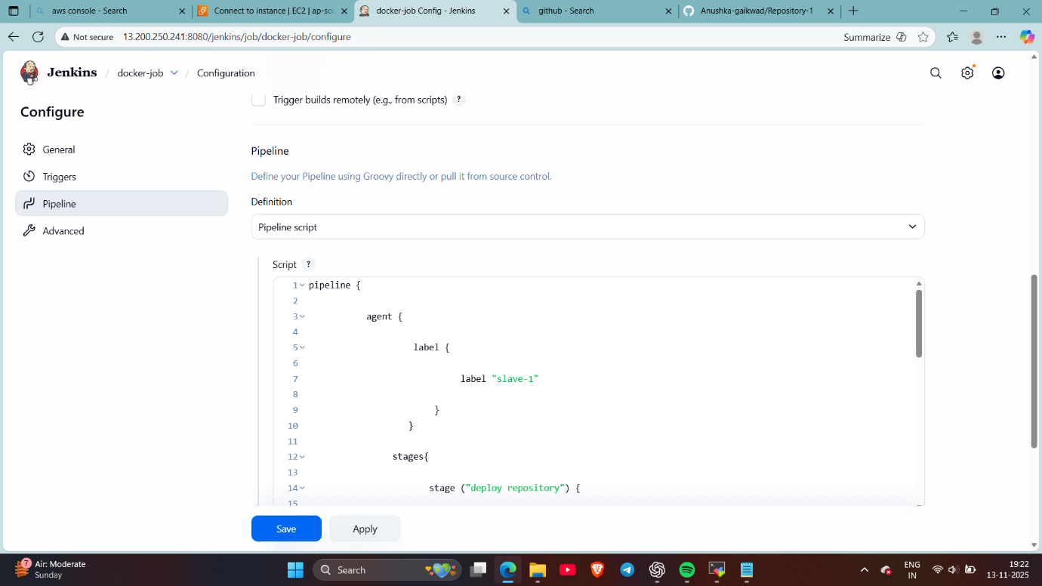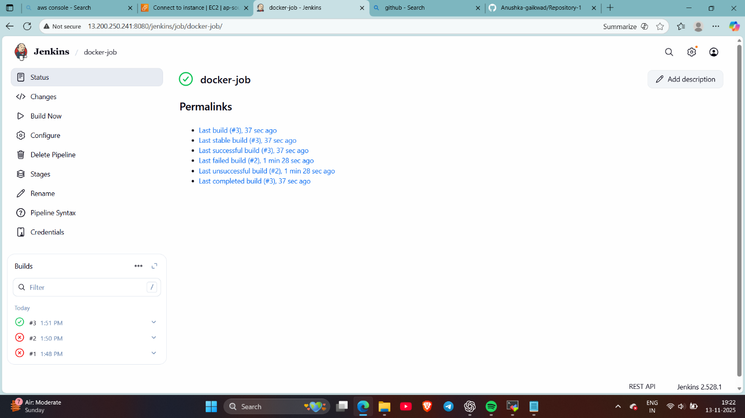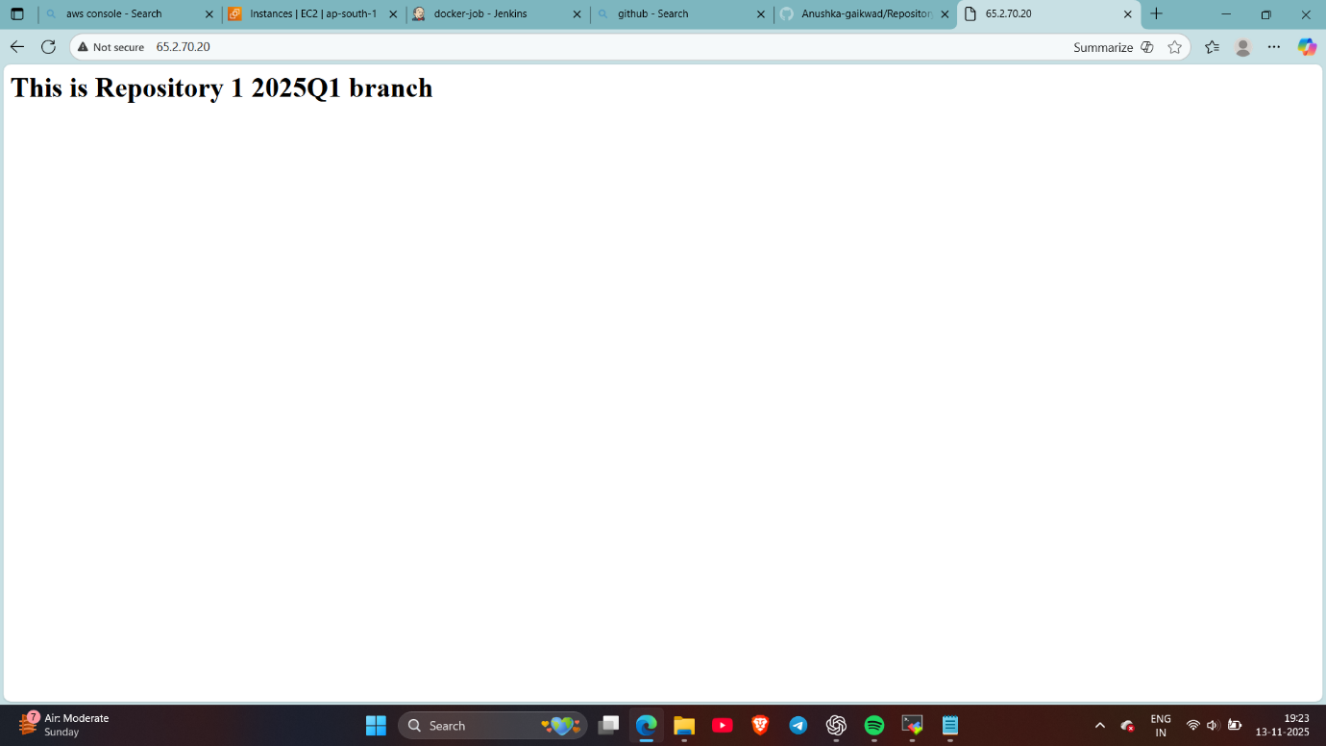
Checked..

- Create a job-2 on Jenkins pipeline in which I’ve first deployed my index file from my git repo’s 2025Q2 branch , created custom bridge network, created container and binded over port 90, and copied file in container
pipeline {

agent {

label {

label "slave-1"

}
}

stages{

stage ("deploy repository") {

steps {

echo "cloning repository..."
git branch: '2025Q2' , url: 'https://github.com/Anushka-gaikwad/Repository-2.git'

}
}

stage ("deploy file") {

steps {

script {

sh '''
sudo docker rm -f c2
sudo docker run -dp 90:80 --name c2 --network test httpd
sudo docker cp index.html c2:/usr/local/apache2/htdocs

'''

}

}

}

}

}
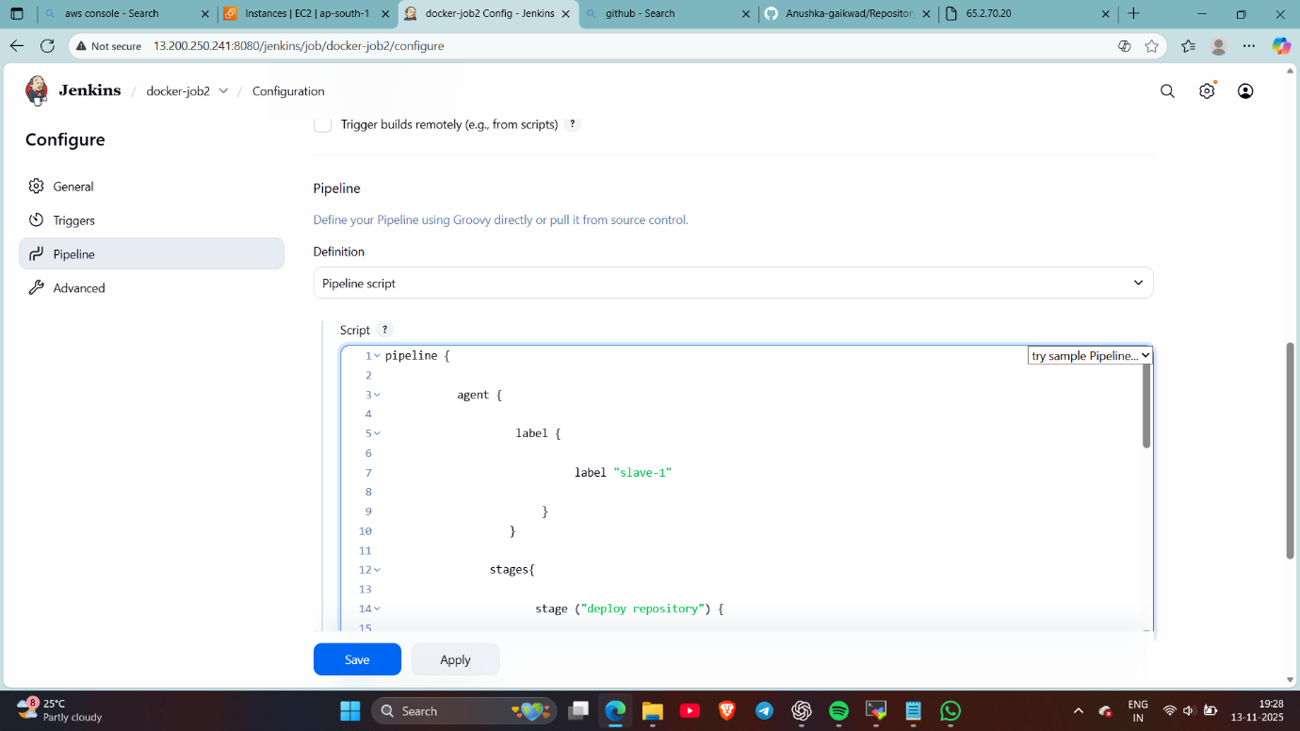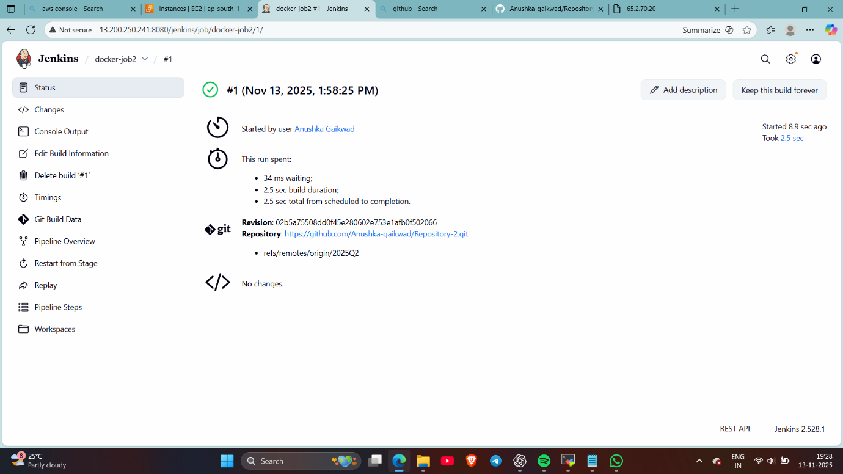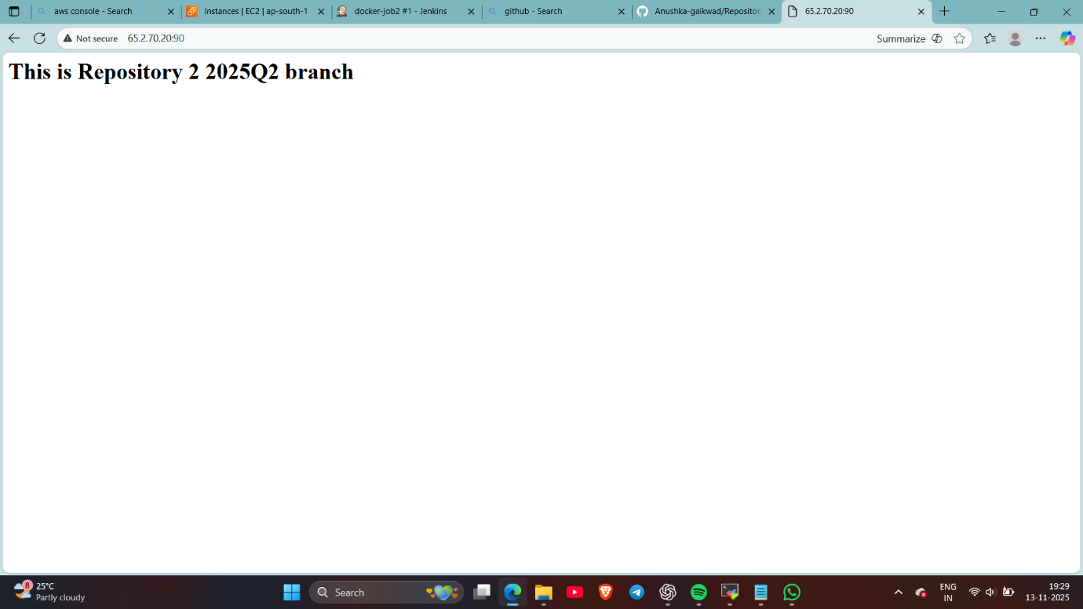
Done….

